Lebanese American University



Electrical and Computer Engineering Department

Vertically Integrated Project

Business Model Development and Technical Design of Shared Renewable Energy System in Urban Areas

Dr. Nagham El Ghossein

Jennifer Mitri 202001080
Mohannad Akoum 202001455
Tatiana Yazbek 202100576
Date: December 17th, 2023
Table of Contents
Introduction 5
Communication Interface 6
Recap 6
Inverters in Lebanon 6
Deye Hybrid Inverter 6
Voltronic Solar Inverter 7
SUNPOLO Series 8
Felicity Solar Inverter 9
Sumry HPS Series 9
New Energy Solar Inverter 10
Initial Communication Interface 12
Communication between Smart Meters and Inverters 12
Communication between the Smart Meter and the Data Concentrator 13
Communication between Inverter and User 14
Communication between Inverter and Data Concentrator: 14
Application of the Communication Interface 14
Communication between the Smart Meters and the Data Concentrator 15
Communication between the Inverter and the Smart Meters 15
Communication between the Inverter and the Data Concentrator 15
Solar Inverter’s API 15
Subsequent Communication Interface 16
Integration of the Remote Terminal Unit 17
Supervisory Control and Data Acquisition 18
Remote Terminal Unit 18
Updated Communication Interface 21
Modbus Protocol 23
Final Communication Interface 25
Future Steps 28
Conclusion 29
References 30

Table of Figures
Figure 1: Deye Hybrid Inverter 7
Figure 2: Voltronic Solar Inverter 7
Figure 3: SAKO SUNPOLO Series Inverter 8
Figure 4: Felicity Solar Inverter 9
Figure 5: Sumry HPS Series Inverter 10
Figure 6: New Energy Inverter 11
Figure 7: Initial Assumption of the Communication Interface 12
Figure 8: Updated Communication Interface 16
Figure 9: RTU Hardware Components 19
Figure 10: Modules of the FPGA-based RTU 21
Figure 11: SCADA System Configuration 22
Figure 12: Updated Communication Interface 22
Figure 13 - Xilinx’s Spartan III FPGA 23
Figure 14 - DinBox RTU M4 24
Figure 15 - DinBox RTU Q7 24
Figure 16 - Conext™ CL125 Inverter 25

Table of Tables
Table 1: Specifications of the Hybrid Deye Inverter 7
Table 2: Specifications for the Voltronic Solar Inverter 8
Table 3: Specifications of SAKO SUNPOLO Series Inverter 8
Table 4: Specifications of the Felicity Solar Inverter 9
Table 5: Specifications of the Sumry HPS Series Inverter 10
Table 6: Specifications for the New Energy Inverter 11
Table 7: Relay Switch Models 27

Introduction

The recurrent electricity cuts in Lebanon have been a subject of concern over the years. To put things into perspective, in summer of 2013, Beirut suffered from nine hours of electricity cuts daily. Also, in 2018, the city of Saida suffered from fifteen hours of electricity cuts daily. [1] In fact, the state of electricity worsened even further especially after the severe economic crisis Lebanon is passing through. Electricity cuts increased massively, reaching up to twenty hours or even full day blackouts. This significantly increased the price of electricity produced by the Electricité du Liban (EDL) and by the informal private electricity sector. Due to these high prices and the instability of these sectors, the Lebanese people took the situation into their own hands by installing Photovoltaic (PV) panels, inverters, and batteries to generate their own electricity. This current situation paved the way for Takatom to introduce the concept of creating microgrids within the Lebanese infrastructure to establish peer-to-peer energy trading platform. This platform aimed at utilizing the excess unused energy generated by the PV panels throughout the day to satisfy the demand of other consumers within the microgrid at competitive prices. However, enacting such a platform is accompanied by multiple struggles on the economic, legal, and technical levels. One of the main struggles faced by this platform is creating a proper Communication Interface between the components of the system to ensure safe, reliable, and stable operation.

Communication Interface

Recap
In the first few weeks of the semester, we went over the previous reports that were written by previous members of the VIP program. These reports provided us with an overview of the project as a whole. They introduced us to the concept behind Takatkom and the progress reached by all the teams on the economic, legal, and technical level. During this period, we were also introduced to the main task we would tackle during this semester. This tackle consisted of creating a communication interface for the peer-to-peer energy trading platform that aimed at safely collecting the data for billing purposes and protecting the grid from any faults by establishing a remote control over the inverters.

Inverters in Lebanon
Based on this foundation, we decided to tackle our first task for the semester. The task was composed of getting the datasheets of the inverters traded in the Lebanese Market with the focus on their communication capabilities.

In Lebanon, the demand for inverters has experienced a notable surge due to various factors such as frequent power outages and the increasing adoption of renewable energy sources. Inverters play a crucial role in addressing the challenges posed by unstable electricity supply, serving as a bridge between conventional power sources and alternative energy systems. Moreover, the inverters play an essential role in the PV systems by inverting the DC current generated by the solar panels to AC current used in the households. [2]

Here are some of the inverters readily available in Lebanon:

Deye Hybrid Inverter
The SUN 3/6K-SG04 hybrid inverter stands out as an ideal choice for both residential and light commercial applications in Lebanon. An interesting alternative in the Lebanese market is the 5KW Deye inverter, competitively priced at $880. [3]
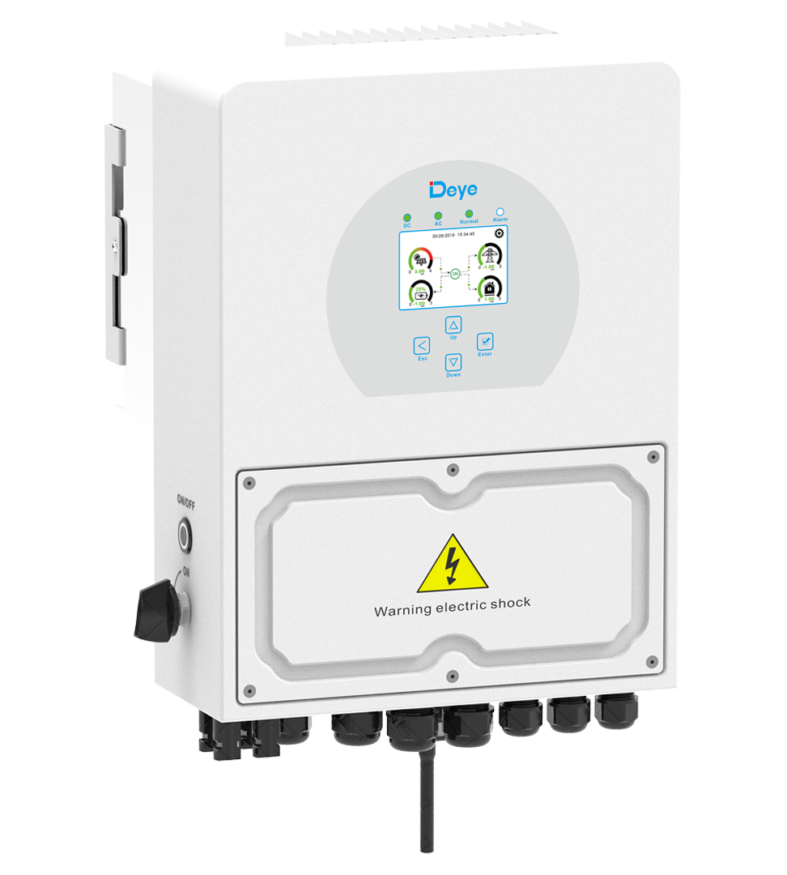
Figure 1: Deye Hybrid Inverter
Specifications
Battery |  | PV Input |  | AC Output |  | General
Type: | Lead-Acid/Lithium-ion (20-30V) | Max DC Power: | 3900W | Rated/UPS Power: | 3000W | Temp Range: | -40°C to +60°C
Max Charge/Discharge: | 140A | Rated PV Voltage: | 370V (125-500V) | Max AC Power: | 3300W | Communication: | RS485/CAN Port
Charging: | 3 Stages/Equalization | MPPT Range: | 150-425V | Max AC Current: | 15A | Weight: | 14kg
Li-ion: | Self-Adaptive to BMS | Max PV ISC: | 17A | Continuous Passthrough: | 35A | Protection: | IP65 (Dust/Water Jets)
Table 1: Specifications of the Hybrid Deye Inverter

Voltronic Solar Inverter
The Voltronic Solar Inverter 5500W Hybrid is tailored for both residential and light commercial applications. The 5.5KW Voltronic inverter is competitively priced at $450 in the Lebanese market. [4]
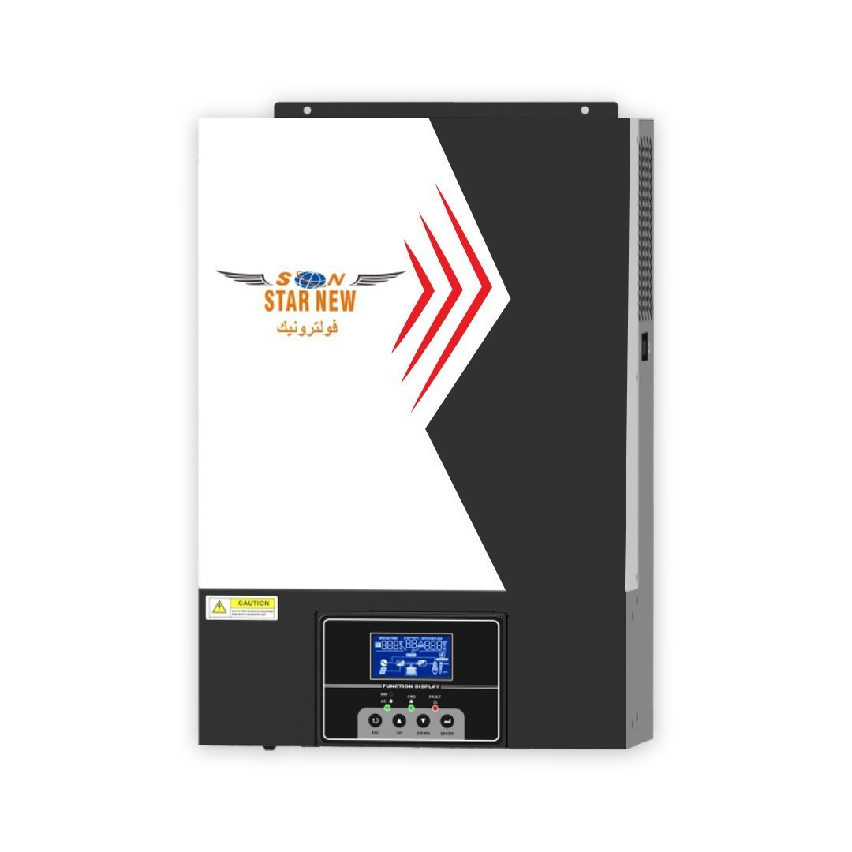
Figure 2: Voltronic Solar Inverter

Specifications
Input Data |  | Output Data |  | Solar Charger |  | Physical
Voltage: | 230VAC | AC Voltage Regulation: | 230VAC ± 5% | Max PV Array Power: | 6000W | Dimensions | 400x300x100 (mm)
Selectable Voltage Range: | 90-280VAC (for home appliances) | Surge Power: | 11000VA | MPPT Range: | 120-450VDC | Communication: | LCD/RS232 GPRS/Wi-Fi
Frequency Range: | 50Hz/60Hz (Autosensing) | Transfer Time: | 20ms (for home appliances) | Max PV Array Open Circuit Voltage: | 500VDC | Weight: | 12kg
Battery Voltage: | 48VDC | Waveform: | Pure Sine Wave | Max Charging Current: | 100A | Max Efficiency | 98%
Table 2: Specifications for the Voltronic Solar Inverter

SUNPOLO Series
The Sunpolo Inverter, tailored for residential and light commercial applications, stands out as a versatile hybrid solution that seamlessly integrates grid-tie and hybrid functionalities. In the Lebanese market, the 5KW Sunpolo Inverter presents an attractive option at a competitive price point of $275. [5]
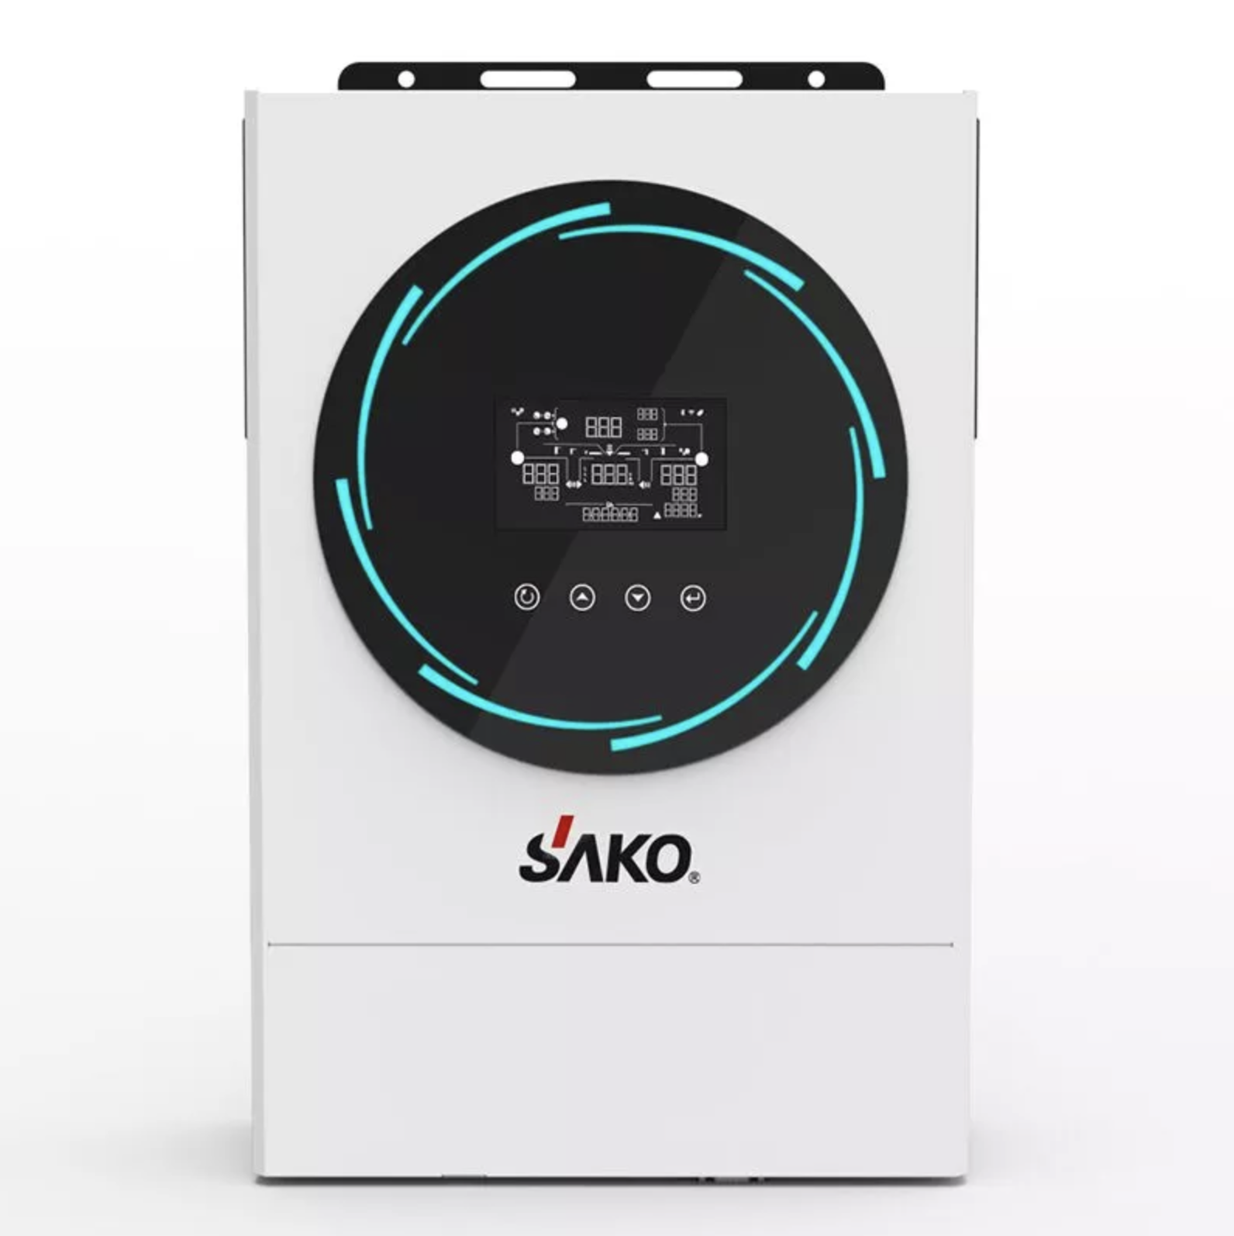
Figure 3: SAKO SUNPOLO Series Inverter
Specifications
Input Data |  | Output Data |  | Physical
Voltage: | 230VAC | Nominal Output Voltage | 220/230/240 VAC | Weight | 10kg
AC Startup Voltage | 180VAC | Effeciency | 93% | Communication: | RS485/RS232 Wi-Fi
Maximum Input Current | 40A | Waveform: | Pure Sine Wave | Max Effeciency | 96%
Table 3: Specifications of SAKO SUNPOLO Series Inverter

Felicity Solar Inverter
The Felicity Inverter emerges as a versatile energy solution, catering to both grid-tie and backup applications with its impressive features. Inverter offers a compelling option competitively priced at $320. [6]
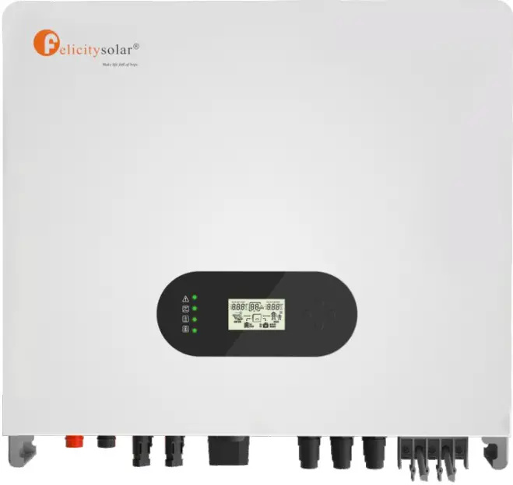
Figure 4: Felicity Solar Inverter
Specifications
Power Input and Output: |  | Battery Details: |  | Photovoltaic (PV) Input: |  | Physical
Nominal Input Voltage: | 230VAC | Battery Voltage Range: | 40V to 60V | Max Recommended PV Power: | 6000W to 6500W | Communication: | RS485/Wi-Fi
Max AC Output Power: | 4600W to 5000W | Max Charging Current: | 100A | Max PV Voltage: | 550V | Max Efficiency | 98%
Max Charging Current: | 100A | Max Discharging Power: | 4600W to 5000W | MPPT Voltage Range: | 100V to 500V
Max Output Current: | 25A | Battery Type: | Li-Ion / Lead Acid | Max PV ISC: | 17A
Table 4: Specifications of the Felicity Solar Inverter

Sumry HPS Series
The Sumry Inverter, tailored for personal and home use, is a versatile power solution. In the Lebanese market, the 1.5KW Sumry inverter is attractively priced at $200. [7]
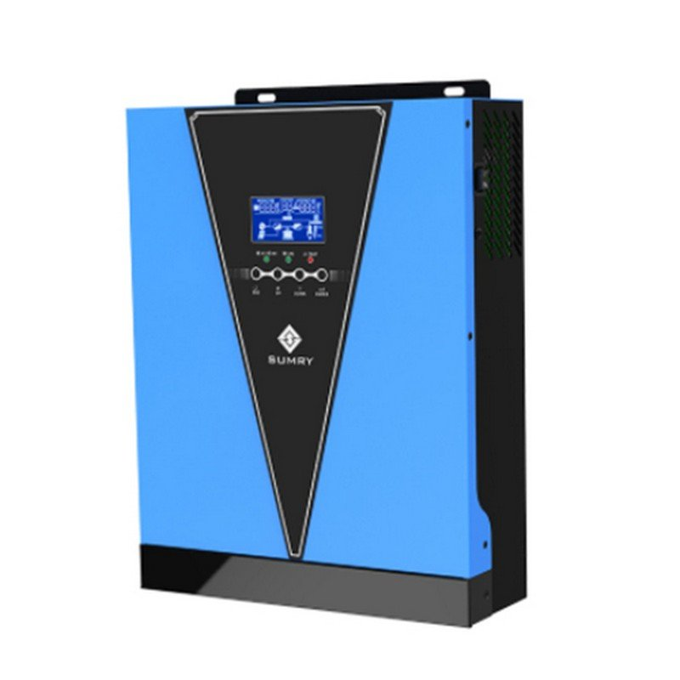
Specifications
Power Input and Output: |  | Battery & AC Charger: |  | Solar Charger: |  | Physical
Nominal Input Voltage: | 230VAC | Battery Voltage: | 12V | MPPT Range at Operating Voltage: | 12-20VDC | Dimensions: | 305x272x100mm
Surge Power | 3000VA | Floating Charge Voltage: | 13.5VDC | Max PV Array Open Circuit Voltage: | 55VDC | Weight: | 5.2kg
Wave Form: | Pure Sine Wave | Overcharge Protection: | 15V | Max Charging Current: | 70A
Frequency Range: | 50Hz/60Hz (Autosensing) | Max AC Charging Current: | 10A/20A | Standby Power Consumption: | 2W
Figure 5: Sumry HPS Series Inverter
Table 5: Specifications of the Sumry HPS Series Inverter

This inverter does not support any form of communication. However, the Sumry HGS Series supports both the RS485 and Wi-Fi modules.

New Energy Solar Inverter
The New Energy Inverter stands out as a versatile and efficient power solution. In the Lebanese market, the 3.5KW New Energy Inverter is attractively priced at $200. [8]
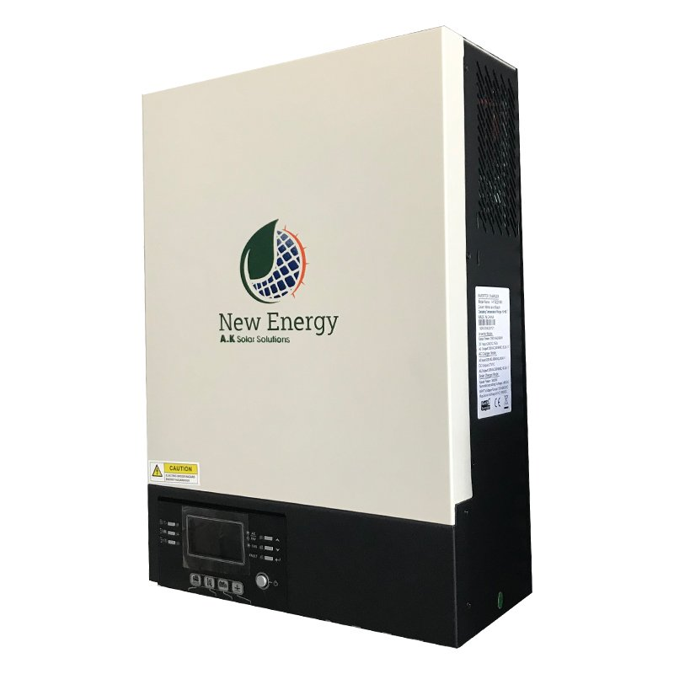
Figure 6: New Energy Inverter
Specifications
Power Input and Output: |  | Battery & AC Charger: |  | Solar Charger: |  | Physical
Nominal Input Voltage: | 230VAC | Battery Voltage: | 48V | MPPT Range at Operating Voltage: | 120-450VDC | Dimensions: | 115x300x400mm
Surge Power | 11000VA | Floating Charge Voltage: | 54VDC | Max PV Array Open Circuit Voltage: | 500VDC | Weight: | 10kg
Wave Form: | Pure Sine Wave | Overcharge Protection: | 63V | Max Charging Current: | 80A | Communication | USB/Bluetooth RS232/RS485
Frequency Range: | 50Hz/60Hz (Autosensing) | Max AC Charging Current: | 60A
Table 6: Specifications for the New Energy Inverter

Initial Communication Interface
After inspecting the different communication modules in the inverters available in Lebanon, our next task was to try and establish an initial assumption of the communication interface. The objective is to develop a robust smart metering and solar power system with advanced data management and control capabilities.

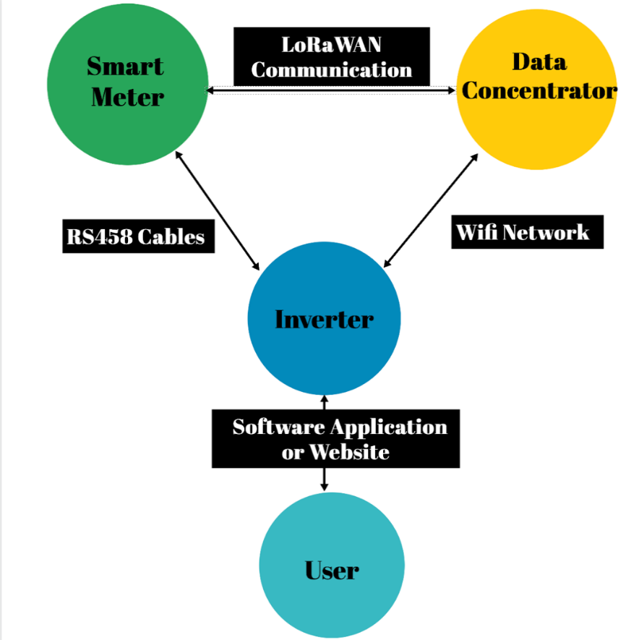
Figure 7: Initial Assumption of the Communication Interface

Communication between Smart Meters and Inverters
Wired communication is usually preferred between the Smart Meters and the Inverters given the close proximity of the components. This wired connection is viable via two different methods: Power Line Communication (PLC) and RS485.

The implementation of the PLC approach for smart meters depends on the substantial losses in power lines, which depend on both the quality of the power lines and the demand load across them. [9] In Lebanon, the overloaded nature of the power lines and the significant losses across them further complicate the feasibility of this approach. That is why, in our approach, communication between the inverter and the smart meter is done through an RS485 cable which is a bidirectional cable as shown in figure 7.

This type of communication is beneficial for several reasons which include:
Optimizing Self-Consumption: By communicating with the smart meter, the inverter can better align its operation with the building's electricity consumption patterns. For example, the inverter can increase solar power production when the building's demand is high, ensuring that more of the solar energy is used on-site rather than being exported to the grid.
Grid Interaction: Communication between the inverter and the smart meter ensures that the energy consumed and produced is accurately measured and reported. This data is used by the energy trading platform for billing purposes.
Efficiency: Communication between the inverter and the smart meter enhances the functionality and efficiency of a solar power system. It enables better coordination between electricity generation and consumption. [10]

Communication between the Smart Meter and the Data Concentrator
The communication between the Smart Meter and the Data Concentrator can be established through wired and wireless connections. When it comes to wired connections, usually RS485 cables are used. However, in the context of a relatively large-scale model, wired communication among smart meters using RS485 cables is challenging, as their reach is limited to 1.2 km. As for the wireless connections, they are divided between optical fiber, Wi-Fi, and Long-Range Wide Area Network (LoRaWAN) technologies. Even though Optical fibers provide high speed data transmission, they were not chosen as a communication solution due to their expensive nature. Communication between Smart Meters and the Data Concentrators is usually real-time which makes Wi-Fi implementation difficult. In Lebanon, Wi-Fi connections are usually slow and unreliable making it impractical for real time applications. That is why LoRaWAN technology was used as shown in figure 7.

LoRaWAN technology is a communication protocol which provides long-range communication with the ability to penetrate obstacles at low power consumption. This technology requires the establishment of a gateway to facilitate communication with a range up to 5 km. [11] One data concentrator can connect with 1028 smart meters at the same time. Therefore, every single smart meter is associated with a Device Extended Unique Identifier (DevEUI) to associate the data sent with a specific device. These DevEUIs are stored in a map data structure with the resident’s owner names serving as the keys. [12] This implementation facilitates the billing calculations as the data ,which represents the energy consumed and produced, can be associated with the respective residences. In addition to that, the LoRaWAN technology provides security features as it ensures the protection of the data during transmission and the authentication of the devices.

Communication between Inverter and User
For this type of connection to be established, the Inverter must be connected to the residence’s Wi-Fi network. All of the inverter’s parameters and current operation status are displayed on the inverter’s website or application. In addition to that, any error or fault during operation is displayed there. The application or website allows for a manual remote shutdown of the inverter itself. At any time, the residents or owners can access these information through the application or website which are protected by a username and a password as shown in figure 7.

Communication between Inverter and Data Concentrator:
The data concentrator operates with dual communication capabilities, employing both optical fiber and LoRaWAN. Through the optical fiber, the data concentrator uploads the data collected from the smart meters to Google Cloud or Amazon Web Services (AWS). This provides unlimited storage and allows for the integration of AI models to process the data extensively and to optimize the pricing units. Despite the high price of the optical fiber, it can be implemented here due to the low number of data concentrators and the need for high-speed data transmission when uploading a large amount of data.

Moreover, the data concentrator assumes the role of monitoring the inverters via network connections as shown in figure 7. In the event of an error, the data concentrator promptly sends a signal, initiating a remote shutdown of the faulty inverter to prevent the error from cascading across the entire grid.

Application of the Communication Interface
Based on the foundation of the initial communication interface, our third task was to try and implement this interface on the 4TGB Model Data Concentrator and the 5TCM Smart Meter.

When it comes to applying any communication interface, the first step is to make sure that the two devices in consideration have the same communication protocol. Both the 4TGB Model Data Concentrator and the 5TCM Smart Meter support DLMS/COSEM communication protocol. This communication protocol is an international standard (IEC 62056) commonly used between smart meters and data concentrators as it defines a set of layers for remote reading and management of the meters.

Communication between the Smart Meters and the Data Concentrator
As per the datasheets of both devices, PoweRline Intelligent Metering Evolution (PRIME) is the only common form of communication protocol between both devices. PRIME is a specific communication technologies for data concentrator and smart meters that lies under the umbrella of PLC.

PRIME communication technology offers efficient cost-effective real-time communication between the data concentrator and the smart meters using the existing power lines. It enhances the grid’s efficiency and allows for remote management of the smart meters by allowing the energy trading platform to perform updates on the smart meters without being in physical contact with them. [13]

Communication between the Inverter and the Smart Meters
The 5TCM Smart Meter supports the RS485 port making it suitable for the communication explained in the previous section.

Communication between the Inverter and the Data Concentrator
The 4TGB Model Data Concentrator supports a 3G communication module making it suitable for the communication explained in the previous.

Solar Inverter’s API
After implementing the communication interface, our fourth task was to try and search the internet for Application Program Interface (API) of the solar inverters used in the market.

Basically, an API is a set of protocols and programs that allow different software components to communicate with each other. It defines methods that the components use to request and exchange information. APIs are divided into many categories including Web APIs, that facilitate the communication over the internet, library APIs, that provide a set of functions for programmers to use, and operating system APIs, that allow application to communicate with the underlying operating system. [14]

Unfortunately, the solar inverter’s APIs cannot be found online. There is almost no information regarding them. This proves to be problematic down the line in our progress with the communication interface.

Subsequent Communication Interface
After meeting up with Vladimir and discussing the communication interface even further, we decided to update our communication interface.

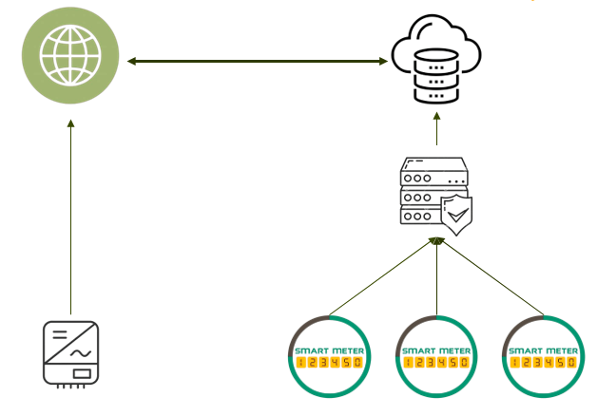
Figure 8: Updated Communication Interface

From our discussion, we realized that the data concentrator is considered a “dummy” device. This means it can only store information and then upload it to the cloud. It is not capable of monitoring the inverters and then sending a signal to turn them off remotely. Therefore, the wireless communication between the inverter and the data concentrator needs to be removed completely.

As for the remote control of the inverter, this would be extremely challenging given the non-disclosure of the solar inverter’s APIs. These APIs are needed to be able to properly send a control signal to remotely shut down the inverter. However, we were able to establish a general idea of how to do it.

From the previous section, we know that the inverter can be remotely turned off through the online webpage or application and that our data will be uploaded and manipulated on the cloud. In case of an error, by utilizing the network, the server would send an HTTP request knowing the control signals of the solar inverter forcing a remote shutdown.

This scenario was implemented only in Australia. They have the capability of shutting down around 60,000 inverters in the click of a button. To do so, they inserted a USB to every single inverter after getting the approval of the inverter’s manufacturers for copyright reasons. This USB alters the API of the solar inverter in a way that allows it to be turned off remotely by sending a simple HTTP request.

The problem with our approach is that we do not have access to this API. Solar Inverter companies ,that are already selling millions and millions of inverters, would not be willing to disclose their API unless being approached by a serious business deal that would generate a lot of profit. However, in the early stage of Takatkom, this is still not achievable.

Integration of the Remote Terminal Unit

After failing to bypass the need for the solar inverter API, Mr. Samir Tayyar, an Electrical Engineer with 30+ years of experience, was contacted. In our meeting, he reaffirmed that the data concentrator was a completely unidirectional device that couldn’t transmit any instructions to the inverter. Also, he informed us of the existence of a Remote Terminal Unit (RTU) that could be connected to multiple inverters via RS485 cables using the Modbus protocol. The RTU would be controlled remotely by its Master Terminal Unit (MTU) and user interface. These RTUs put together would form a Supervisory Control and Data Acquisition (SCADA) system able to monitor and control the user’s inverters.

Supervisory Control and Data Acquisition

Definition
SCADA systems refers to a comprehensive control system architecture that is widely used in various industries to monitor and control processes and infrastructure in real-time. SCADA systems play a crucial role in managing and optimizing complex processes, ensuring efficiency, reliability, and safety. [15]

Functionality
The SCADA system is heavily RTU-based. The process of transferring and receiving commands and data is categorized in five distinct steps.
- Data Collection: The system will collect the information from the available RTUs.
- Data Transfer: The RTU will transfer the data to the MTU using wireless connections.
- Data Processing: MTU will process the data acquired to carry out any necessary analysis and control.
- Data Display: The data will be displayed on the operator/user’s screens.
- Data Control: MTU will send control actions to the RTUs based on the analysis of the data. [16]

Remote Terminal Unit

Definition
After defining the SCADA system, let us delve into the specifications of the RTU. RTU is a microprocessor-based device, designed as an interface between the central control system and field devices, facilitating remote monitoring and control. ​In this context, RTUs are perfect for peer-to-peer energy trading and controlling the inverters of a neighborhood-wide platform.

Functionality
The RTU has many functionalities including data acquisition. An RTU has the capability of collecting data from various input channels including the user inverters. This functionality can replace the data concentrator as it can do the exact same task and getting two devices that have similar capabilities would be redundant. The second functionality of the RTU would be its control capabilities. An RTU can execute control commands based on received data. These commands range anywhere from adjusting setpoints to activating/deactivating equipment. Our project focuses on controlling the user inverters, making this functionality the reason we started looking into the RTUs in the first place. The last functionality would be real-time communication with the central control system. The RTU can communicate using several protocols ,including Modbus, making the exchange of instructions and data much faster.

Components
An RTU is formed of a processor that will ensure its functionalities, I/O modules that will be connected to the user inverters, and the different communication ports and modules. Every RTU must have a DC Power Supply to ensure its continuous operation as well as a memory unit to ensure the storage of the data that is being transmitted.
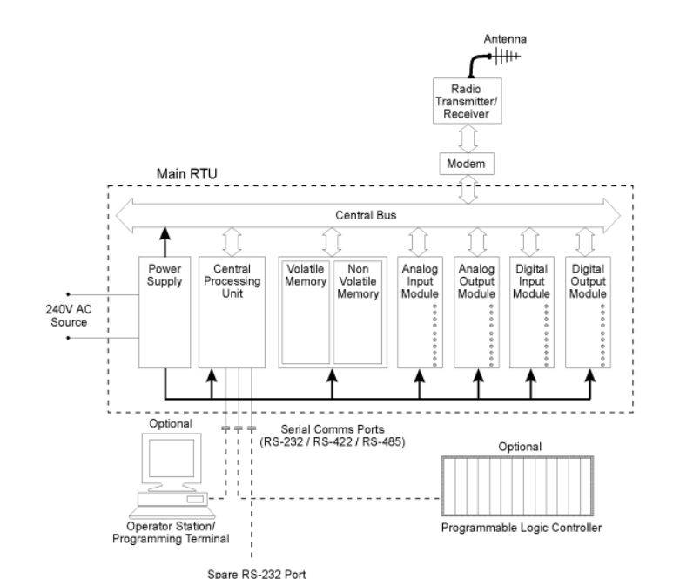
Figure 9: RTU Hardware Components

Configuration
The RTU can be configured using two types of configuration:
- Dynamic Configuration: RTUs often support the dynamic downloading of configuration and control programs from a central station. This flexibility allows for remote adjustments and updates.
- Local Configuration: There's a provision for local configuration using an RTU programming unit. This allows on-site adjustments and programming without relying on a central station.

Types
After thorough research, we came across two types of RTUs: Programmable Logic Controller (PLC)-Based RTU and the FPGA-based RTU. Both have the same functionality but have different performance capabilities.

Starting with the PLC-based RTUs, they combine the functionalities of both PLCs and RTUs. A PLC is a specialized large-scale microcontroller that is used in industrial applications. It is used to automate machine functions in harsh environments.
Advantages:
- Industrial Robustness: PLCs are known for their robustness and reliability. In harsh environments, where stability is needed, PLC-based RTUs shine. ​
- Simplicity in Programming: Programming PLCs is generally straightforward. This simplicity can lead to quicker implementation.
Disadvantages:
- Limited Flexibility: PLCs may struggle with the rapid adaptability required in certain dynamic energy management scenarios limiting their effectiveness.​
- Single-Threaded Processing: PLCs often rely on single-threaded processing. This sequential execution may introduce delays in response times which may impact real-time performance.
In theory, the PLC-based RTU is not really what we are looking for in this project. Its lack of flexibility will not permit us to override the inverter’s API and the single threading might make our entire process delayed, thus slowing down our implementation.

Moving on to the Field-Programmable Gate Array (FPGA) based RTUs, they are integrated circuits that provide flexibility to the users by allowing them to tailor the RTU for their specific needs.
Advantages:
- Adaptability: FPGAs are capable of frequent adaptation. This dynamic flexibility suits energy management systems. ​
- Multi-Threaded Processing: The parallel processing capability of FPGAs enables simultaneous execution of multiple tasks. This translates to faster response times, which is crucial for real-time control in energy applications. ​

- Tailored Precision: FPGA-based RTUs allow for tailoring to specific application requirements maximizing its efficiency.
Disadvantages:
- Complex Programming: The high adaptability of FPGAs comes at the cost of complex programming.​
- Cost Considerations: FPGA-based RTUs are relatively expensive.

We can conclude that the FPGA-based RTU has an advantage over the PLC-based RTU in wireless SCADA systems. Additionally, the FPGA-based RTU allows us to override the solar inverter’s API.

Updated Communication Interface
After this breakthrough, we decided to update our communication interface yet again. First, we will discuss the modules of the FPGA-Based RTU.
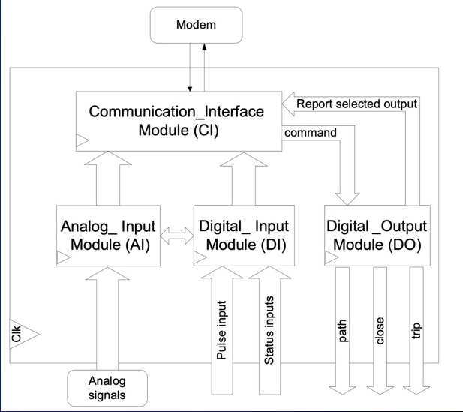
Figure 10: Modules of the FPGA-based RTU
The FPGA-based RTU will communicate with the SCADA system using a Wi-Fi connection. Some FPGA-based RTUs communicate with an external modem via an RS232 port as shown in figure 10 whilst others include Wi-Fi capabilities eliminating the need of a modem. Analog Input (AI) and Digital Input (DI) modules monitor analog and digital quantities of the inverter.​ They report changes in these values and deliver new values to Communication and Interface (CI) module simultaneously.​ The CI module is responsible for receiving commands via the serial port and decoding them. It incorporates new values with the date and time of variation and saves this information in its memory.​ When SCADA requests data from the RTU, the CI module sends data packets serially via the RS232 port and through the modem to the SCADA station. [17]

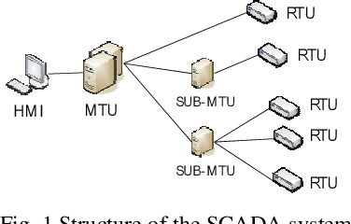
Figure 11: SCADA System Configuration
This RTU will be connected via an RS485 cable to the inverter to monitor its variables and ultimately send them to the SCADA system via a Wi-Fi connection. Also, the RTU might remotely turn off the inverter based on the request of the SCADA system.
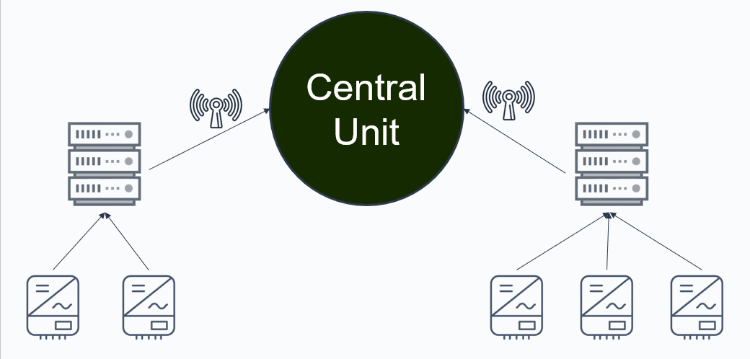
Figure 12: Updated Communication Interface

FPGA-Based RTU Product Review
The only FPGA-based RTU that we could find was the Xilinx Spartan-III FPGA. Based on the research paper, the RTU used was not publicized and it needs more research and reconfiguration of the software.
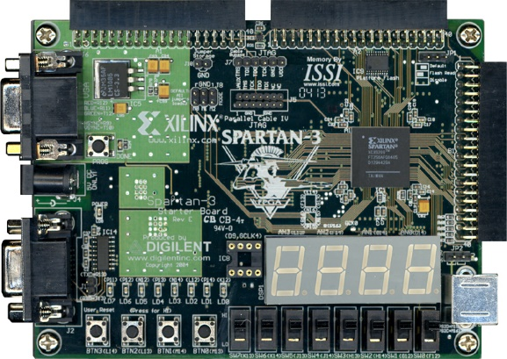
Figure 13 - Xilinx’s Spartan III FPGA
This posed as a limitation for our research as no real device was integrated into the market, making it impossible to find a budget for these types of RTUs. Consequently, we had to get insight from experienced professionals in the field. Naturally, we contacted Eng. Samir Tayyar to understand the availability of the FPGA-based RTU in the market. [17]

Industrial Insight
Following the meeting with Mr. Tayyar, we were made aware of the unavailability of FPGA-based RTUs in the entire market. This product is still in its development stage and is not being used on projects. Mr. Tayyar encouraged us to use the PLC-based RTUs with Modbus protocol without worrying about its previously mentioned slowness. The functionality of the FPGA-based RTU was to turn off the inverter in times of fault. The PLC-based RTU is capable of such a task. Based on the analysis of the data acquired, if the MTU detected a fault, it would send a command to the RTU to manually turn the inverter off. In its turn, the RTU would send a -24V and +24V power surge to the inverter and turn it off.

Modbus Protocol
Afterwards, we were tasked to find RTUs and inverters that can support the Modbus protocol.

Definition
Modbus is a communication protocol implemented using a master-slave relationship. In a master-slave relationship, communication always occurs in pairs: one device must initiate a request then wait for a response, and the initiating device (the master) is responsible for initiating every interaction. [18]

RTUs that support Modbus Protocol
The first RTU we found was the DinBox RTU M4. This RTU is a low-cost micro RTU with built-in wide range AC power supply. The power supply comes with a back-up to ensure continuous communication with the SCADA system even in the event of power outage. The built-in Sierra Wireless communication module allows for direct Wide Area Network (WAN) communication . Everything is managed by a powerful Cortex M4 microcontroller. Finally, the RTU is built into a DIN rail mountable housing. It is priced at €375.
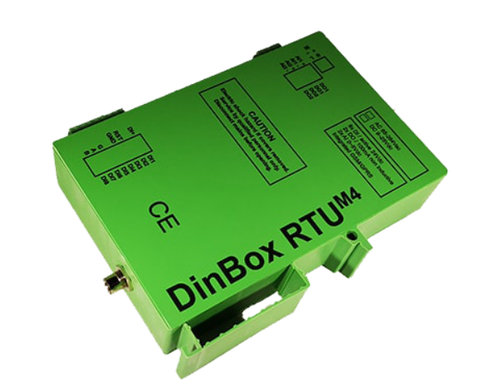
Figure 14 - DinBox RTU M4
The second option we found was the DinBox RTU Q7. This RTU has a WAN communication module for LTE Cat.1, GPRS integrated (other communication possible by changing modules) or can use its Ethernet port as WAN port. This RTU supports I/O extensions. It is priced at €475.
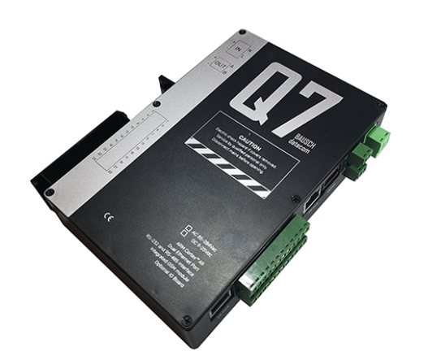
Figure 15 - DinBox RTU Q7

Inverters that support Modbus Protocol
Finding inverters that support Modbus was much less fruitful than we had anticipated. However, we found an inverter that could be compatible with our project if not for its high price. The inverter we found is the Schneider Electric Conext™ CL125 String Inverter. This inverter is the latest three phase string inverter designed for utility scale power plant systems built with 1500V photovoltaic (PV) modules. It is priced at 9,707.00 $.
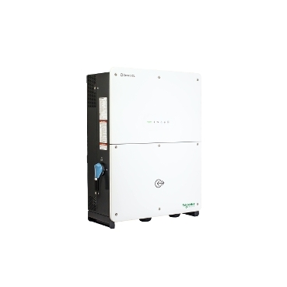
Figure 16 - Conext™ CL125 Inverter

Final Communication Interface
Our previous implementation of the PLC based RTU in the communication interface attempts to force a remote shutdown on the inverters participating in the peer-to-peer energy trading platform. This was done to protect the grid from any fault generated by any of the inverters. As we have previously mentioned, the software structure of the inverter (Inverter registers, API, etc.) is needed to perform such an operation without any wired connection. However, with the integration of the wired connection between the inverter and RTU, this remote shutdown is now possible.

However, after digging deeper into the PLC based RTU, inverter software structure and the main goal behind this type of interface, we decided to make a final modification to this interface to optimize the performance over the entire grid. This modification involves the combination of both the data concentrators and the RTU.

Just like we mentioned before, the smart meters will be connected to the inverters via RS232/RS485 cables. These cables provide bidirectional serial communication between the devices. The smart meters measure the energy flowing into and out of the inverter. These smart meters will be connected via Wi-Fi/LoRaWAN technology to the data concentrator that will store the data measured by the smart meters. This data concentrator will transmit the data to the central unit of the SCADA system for analysis and interpretation. This is exactly like the interface we built before.

Basically, the goal behind this communication interface is to protect the grid. Protecting the grid entails making sure that power supplied equals power consumed during real time, voltage at the load remains constant at a specific value (110Vrms, 220Vrms), and making sure the frequency remains constant(60Hz or 50Hz). Therefore, in case there is a power surplus or deficit in the grid, the SCADA system must have the ability to cut the inverters producing the most power or consuming the most load respectively. This is done to ensure that the frequency in the grid remains constant.

To ensure remote control of the inverters, we will add a basic relay switch that is responsible for controlling the connection between the inverter and the grid. This relay switch can be tripped by sending a low voltage control signal via the RTU. RTU is connected through Wi-Fi to the SCADA system. The RTU will be operating at all times waiting for a signal to be sent by the SCADA system. In case of an error, the SCADA system sends a signal to the RTU to disconnect one of the inverters from the grid. In its turn, the RTU sends a low voltage control signal to the relay through the twisted cables to disconnect the inverter from the grid. Every single RTU will be connected to multiple relay switches to remote control multiple inverters. The number of switches connected to the RTU depends on the number of output signals in the RTU.

This approach handles the case of a mismatch between the power supplied and power consumed. However, when it comes to faults within the inverters themselves, this kind of protection should be handled by inverter manufacturers. All inverters contain self-protection mechanisms to ensure the safe and reliable operation of the inverter. These mechanisms involve protection against over/undervoltage, overcurrent, overtemperature, short-circuit protection and many more.

By doing so, this communication interface is capable of measuring and monitoring the energy consumption/production of every household and sending them to the central unit of the SCADA system for interpretation. It is capable of protecting the grid against power mismatch errors using the RTU and relay switches. However, it relies on the inverter manufacturers to handle the faults that take place within the inverter.

The relay switches that could be used in our system are represented in table 7.

Manufacturer | Relay Switch Model | Prices
Omron | G2R Series | 5.95 $/piece
Siemens | Sirius 3RH2 Series | 44.23 $/piece
Schneider Electric | Zelio RSL1 Series | 16.28 $/piece
ABB | CR-M Series | 10.45 $/piece
TE Connectivity | Potter & Brumfield T9G Series | 10.67 $/piece
Table 7: Relay Switch Models

Future Steps
Following on with the final format of the communication interface, we recommend the future team to first get a full understanding of the material covered so far by the Takatkom team. After doing so, we recommend trying to implement the following communication interface on a small scale. This would require the purchase of a new smart meter due to the lack of a Wi-Fi module in the current smart meter. In addition to that, this would require the purchase of an RTU and a relay switch to implement the full communication interface. However, before purchasing the components, we recommend the future team to communicate with the manufacturer companies to get more information about the components’ functionalities and configuration setups. The reason behind this is that the industrial work is rather different than the theoretical implementation of the communication infrastructure. After successfully running the communication interface, we recommend the future team to work on enhancing the security protocols as it is considered a vital element in data storage and money transaction. Also, we recommend the software team to properly enhance the user interface and experience based on the foundation of the communication interface. Finally, after all of these steps are completed, we recommend the team to start working on scaling the communication interface to the level of implementation on villages and towns in Lebanon. This step requires the collaboration of Takatkom with inverter, smart meter, or data concentrator manufacturers for proper funding of such a huge project.

Conclusion
All in all, the current energy crisis in Lebanon requires innovative solutions, and the proposed peer-to-peer energy trading platform presents a promising avenue. Despite the complexity of such a system, our final communication interface shows promise in implementing it. Overall, the VIP course provided us with a different learning experience than the norm. It allowed us to delve more into the research domain and to interact with the Lebanese market. It explicitly showed us the difference between research, which mainly focuses on the theory and optimization, and industrial solutions which mainly focus on practicality and cost-effective solutions. In addition to that, the VIP course allowed us to work in a multidisciplinary team where every single one of us had to work independently but coherently with the others to complete the tasks by the end of each week. This experience was such a beneficial yet challenging experience that is highly recommended.

References
[1] A. Hably and K. Hajar, “Electricity issues in Lebanon: Let the people talk,” Accueil - Archive ouverte HAL, https://hal.science/hal-02398823 (accessed Dec. 2, 2023).
[2] “Understanding the functions of inverter better: UPS Manufacturers & Dealers in Chennai: Leading ups suppliers,” UPS Manufacturers & Dealers in Chennai | Leading UPS Suppliers, https://www.nantech.in/chennai/inverter/understanding-functions-inverter-better/ (accessed Dec. 4, 2023).
[3] “Sun-3/3.6/5/6K-SG04LP1: 3-6kW: Single phase: 2 MPPT: Hybrid inverter: LV Battery supported,” NingBo Deye Inverter Technology Co.，Ltd., https://www.deyeinverter.com/product/hybrid-inverter-1/sun3-3-6-5-6ksg04lp1-3-6kw-single-phase.html (accessed Dec. 4, 2023).
[4] “Voltronic Solar Inverter 5500W hybrid star new,” Techstore Lebanon, https://techstore-lb.com/shop/solar-inverters/voltronic-solar-inverter-5500w-hybrid/ (accessed Dec. 4, 2023).
[5] “SUNPOLO hybrid inverter 6kw with BMS and RGB,” SAKO, https://sakopower.com/sunpolo-series-6kw (accessed Dec. 4, 2023).
[6] Device. Report, “Felicity solar IVGM4648/2048 MPPT Battery Charge Controller User Guide,” device. Report, https://device.report/manual/7829267 (accessed Dec. 4, 2023).
[7] “HPS series off Grid Solar Inverter,” Sumry Inverter, https://www.sumryinverter.com/product/hps-series-off-grid-solar-inverter/ (accessed Dec. 5, 2023).
[8] “Solar Inverter New Energy 3500W,” Techstore Lebanon, https://techstore-lb.com/shop/solar-inverters/solar-inverter-new-energy-3500w/ (accessed Dec. 5, 2023).
[9] “Power Line Communication,” Power Line Communication - an overview | ScienceDirect Topics, https://www.sciencedirect.com/topics/engineering/power-line-communication (accessed Dec. 5, 2023).
[10] “12 key advantages of RS485 port.,” Shiningltd.com, https://www.shiningltd.com/advantages-of-rs485-port/ (accessed Dec. 5, 2023).
[11] A. Yarali, “IOT: Platforms, connectivity, applications and services,” Amazon, https://docs.aws.amazon.com/iot/latest/developerguide/connect-iot-lorawan-what-is-lorawan.html (accessed Dec. 5, 2023).
[12] “Deveui,” LoRa Developer Portal, https://lora-developers.semtech.com/documentation/tech-papers-and-guides/the-book/deveui/ (accessed Dec. 5, 2023).
[13] Prime: Powerline intelligent metering evolution - researchgate, https://www.researchgate.net/profile/InigoBerganza/publication/4360539_PRIME_Powerline_intelligent_metering_evolution/links/5c9feb2545851506d7361e9f/PRIME-Powerline-intelligent-metering-evolution.pdf (accessed Dec. 4, 2023).
[14] “What is an API? (application programming interface),” MuleSoft, https://www.mulesoft.com/resources/api/what-is-an-api (accessed Dec. 5, 2023).
[15] Supervisory Control and Data Acquisition System (SCADA ... - IEEE xplore, https://ieeexplore.ieee.org/document/4762744/ (accessed Dec. 10, 2023).
[16] M. Aamir, J. Poncela, M. A. Uqaili, B. S. Chowdhry, and N. A. Khan, “Optimal design of Remote Terminal Unit (RTU) for wireless SCADA system for Energy Management - Wireless Personal Communications,” SpringerLink, https://link.springer.com/article/10.1007/s11277-013-1060-9 (accessed Dec. 10, 2023).
[17] RTU hardware design for SCADA systems using FPGA - researchgate, https://www.researchgate.net/profile/Shahab-Ensafi/publication/251993540_RTU_hardware_design_for_SCADA_systems_using_FPGA/links/5450850b0cf24e8f7374bb5a/RTU-hardware-design-for-SCADA-systems-using-FPGA.pdf (accessed Dec. 10, 2023).
[18] “What is the Modbus Protocol & How Does It Work?,” NI, https://www.ni.com/en/shop/seamlessly-connect-to-third-party-devices-and-supervisory-system/the-modbus-protocol-in-depth.html#:~:text=Modbus%20is%20a%20request%2Dresponse,responsible%20for%20initiating%20every%20interaction. (accessed Dec. 10, 2023).

